**FIND BUGS**

1. How many bugs can you find on this buggy windows calculator?  
   Bug Count: Over 5

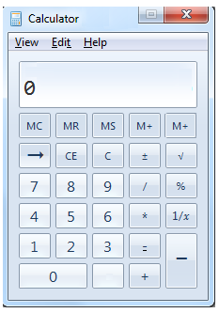

**Example:**

**Bug List**

| **ID** | **Summary** | **Expected result** |
| --- | --- | --- |
| 001 | The ‘Edit’ button has two characters underlined | Remove underline character ‘t’ |
| 002 | Missing minimize button | Add minimize button |
| 003 | wrong button format | Button must have semantics |
| 004 | button wrong position | Change position button ‘ = ‘ and button ‘ - ’ |
| 005 | The result text is not properly positioned | Change position text result to right corner |
|  |  |  |

1. One of the trainee developers has developed a **text pad kind of application**. Below is one of the screenshots of the application. **Can you list out bugs/issues, which the trainee developer should take care of?**

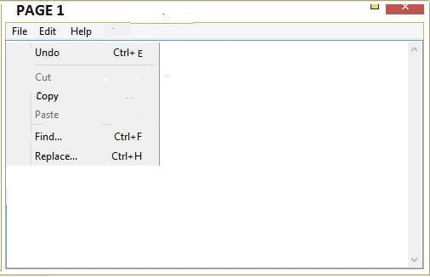

**Sample Answer as a hint:**

The name of the application does not appear in Title space.

| **ID** | **Summary** | **Expected result** |
| --- | --- | --- |
| 001 | Wrong button format | Change button format |
| 002 | Blurred button | Change button format to bold |
| 003 | Charracter “E” is deviated | Change character format "E" |
| 004 | Border left is not valid | Delete border left |

|  |  |  |
| --- | --- | --- |
| 005 | Lack of bottom border | Add border bottom |

1. Weather app has 2 screens, screen 1 displays the weather forecast for first 5 days of the week and screen 2 shows weather forecast for further 5 days. How many bugs can you find on this Weather Forecast screenlet?   
   Bug Count: Over 10

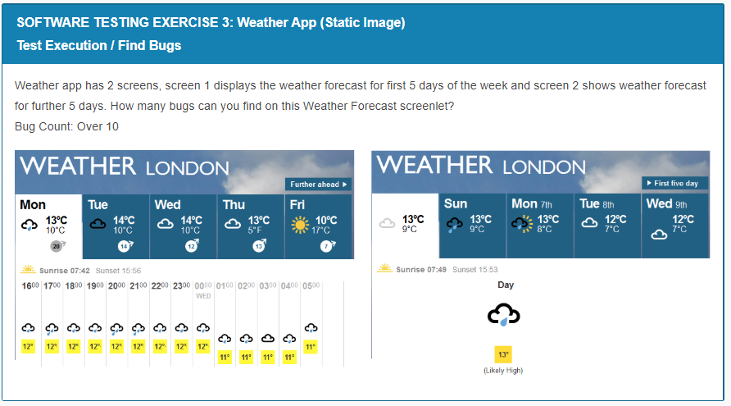

1. As a software tester, what do you do? Of course, testing the software, you would say………Okay, can you find out defects on the page shown below?

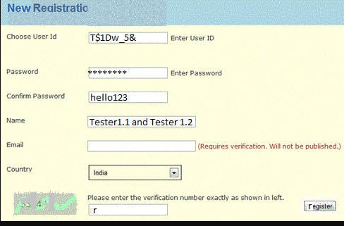

| **ID** | **Summary** | **Expected result** |
| --- | --- | --- |
| 001 | The content of the label is invalid | Change content “Choose” to “Enter” |
| 002 | Wrong color | Change color uniformity |
| 003 | Missing space before input | Add space before input |
| 004 |  |  |
|  |  |  |
|  |  |  |
|  |  |  |